# **Automatic Street Lamp**

# **Project Overview:**

This is a simple project that uses Light Dependent resistor (LDR) to automatically switch on and off the light. Transistor is used as a switch to switch on and off the light automatically.

**Advantages of using automatic street lighting:**

* By using this Automatic system for street light controlling, we can reduce energy consumption.
* In sunny and rainy days, ON and OFF time differ noticeably which is one of the major disadvantage of using timer circuits or manual operation for switching the street light system.

# **Components Used:**

* LDR
* Transistor (BC 547)
* LED
* 9V Power Supply
* 10K Ohm Resistor
* 100K Ohm Resistor
* Breadboard
* 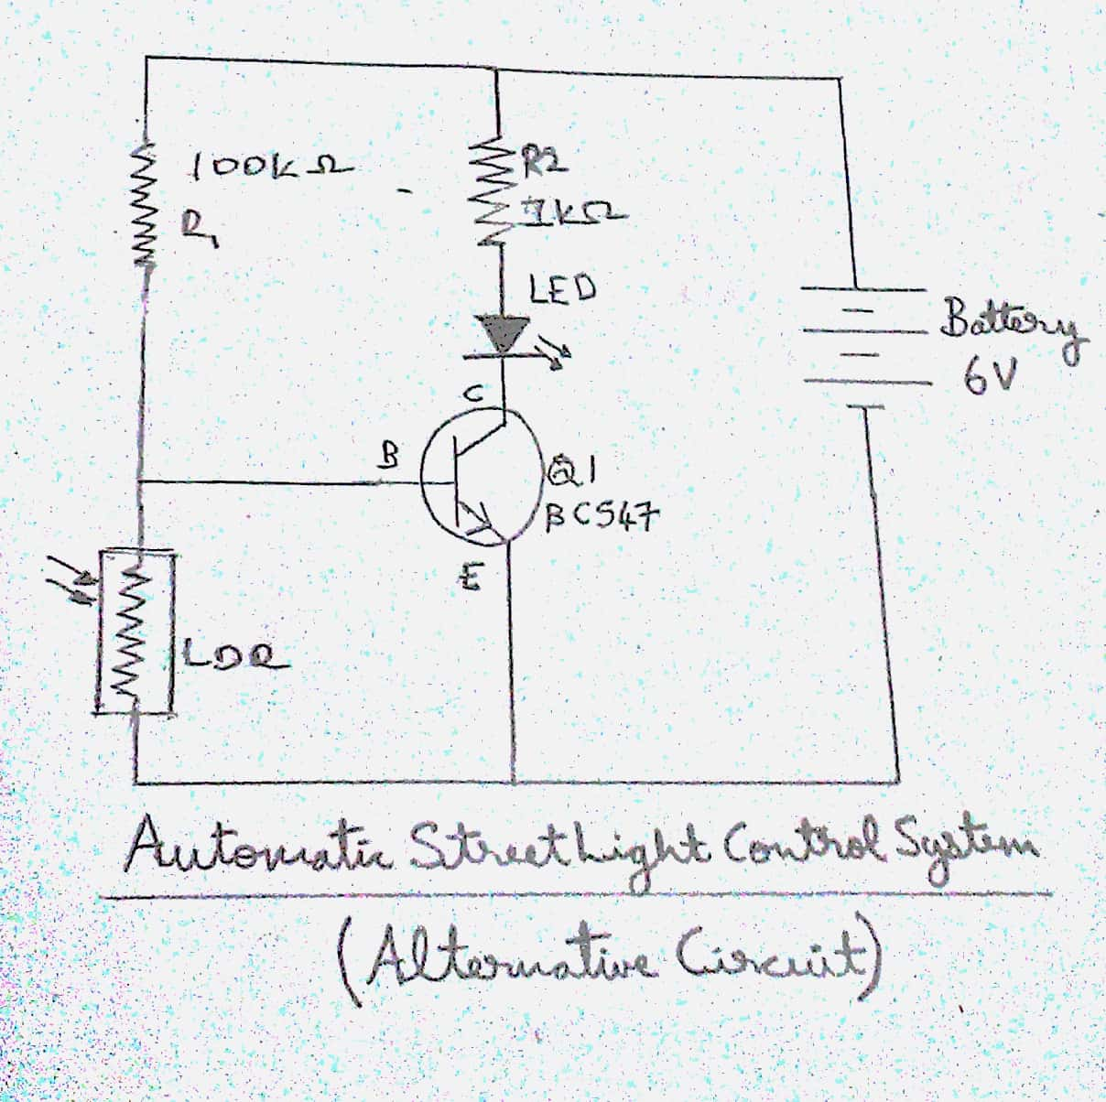Connecting wires

# **Circuit:**

The connections are made as shown.

# **Working:**

When the light is bright, LDR Offers high resistance, and blocks the current. When the light is dim or when there is no light, LDR resistance is low and current is passed. Hence the light glows.

# **Project Photos:**

# **Project By:**

N Nithin Srivatsav

Pareekshith U S Katti

Ponnanna MB

# **Guided By:**

Prof Shobha B S